## **1. Informasi Umum**

## **Nama Penguji**: Ahmad Nizar Riyansyah Sidik

## **Tools Digunakan**: Apache JMeter v5.6.3

## **Nama Test Plan**: Test Plan

## **Jumlah Virtual Users (Thread)**: 10 users

## **Ramp-Up Time**: 1 detik

## **Skenario**: Load testing terhadap endpoint tertentu (silakan sesuaikan jika tahu targetnya)

## Test Scenario

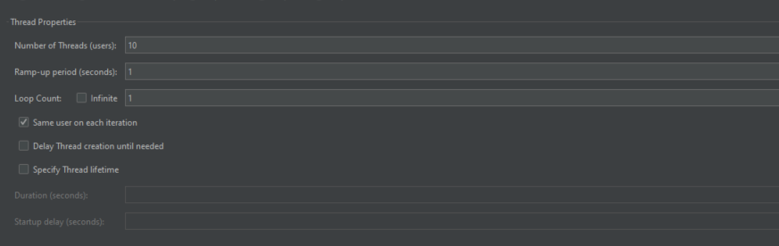

## Key Matric Captured

## Test Result Summary

## Detailed Test Result

### Scenario 1 20 - VU

#### Request Summary

#### Response Time Percentiles

#### Response Time Overview

#### Response Time Percentiles Over Time (successful response)

#### Throughput Hits Per Second

#### Transaction Per Second

#### Response Time vs request